CO4 - Activity 9: Map Storytelling Challenge

Department | AI&DS
Course Code / Course Name | DSA0602/ Data Handling and Visualization
Activity | CO4 - Activity 9: Map Storytelling Challenge
Name | Addula Yaswanth
Register Number | 192324179

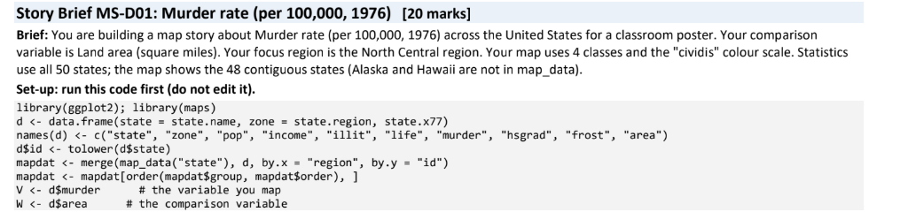

Task 1: The Base Map [4 Marks]
Question: Draw a choropleth map of murder rates across the United States in 1976 using the cividis colour scale. Report the state with the highest rate and its value, the lowest value and the state(s) that have it, and the median of all 50 states.
R code:
# Install packages (run if not installed)
if (!requireNamespace("ggplot2", quietly = TRUE))
install.packages("ggplot2")
if (!requireNamespace("maps", quietly = TRUE))
install.packages("maps")
if (!requireNamespace("viridis", quietly = TRUE))
install.packages("viridis")

library(ggplot2)
library(maps)

# Prepare data
d <- data.frame(
state = state.name,
zone = state.region,
state.x77
)

names(d) <- c(
"state", "zone", "pop", "income", "illit",
"life", "murder", "hsgrad", "frost", "area"
)

d$id <- tolower(d$state)
V <- d$murder
W <- d$area

mapdat <- merge(
map_data("state"), d,
by.x = "region", by.y = "id"
)

mapdat <- mapdat[order(mapdat$group, mapdat$order), ]

# Draw map
ggplot(mapdat, aes(long, lat, group = group, fill = murder)) +
geom_polygon(colour = "white") +
coord_map("albers", lat0 = 29.5, lat1 = 45.5) +
scale_fill_viridis_c(option = "cividis",
name = "Murder rate\n(per 100,000)") +
labs(title = "Murder Rates Across the United States, 1976",
caption = "Source: R state.x77 dataset") +
theme_minimal()

# Statistics
cat("Highest state:", d$state[which.max(V)], "\n")
cat("Highest rate:", max(V), "\n")
cat("Lowest rate:", min(V), "\n")
cat("Lowest state(s):",
paste(d$state[V == min(V)], collapse = ", "), "\n")
cat("National median:", median(V), "\n")
Output:
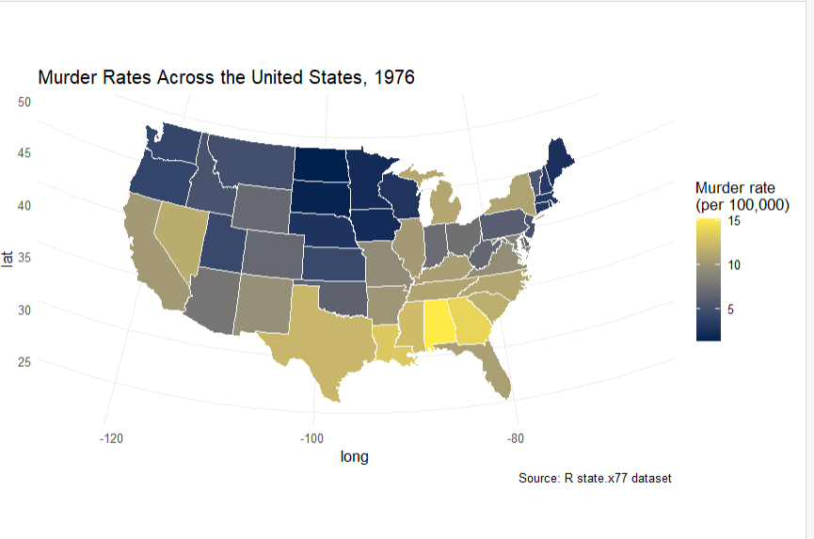
Task 2: The Regional Story [4 Marks]
Question: Calculate the mean murder rate for each of the four regions using tapply(V, d$zone, mean). Identify the highest and lowest regions and the gap between their means. Calculate cor(V, W), describe its strength and direction, and note that correlation is not proof of cause.
R code:
# Setup
d <- data.frame(
state = state.name,
zone = state.region,
state.x77
)

names(d) <- c(
"state", "zone", "pop", "income", "illit",
"life", "murder", "hsgrad", "frost", "area"
)

V <- d$murder
W <- d$area

# Regional means
region_mean <- tapply(V, d$zone, mean)
print(region_mean)

cat("Highest region:", names(which.max(region_mean)), "\n")
cat("Highest mean:", max(region_mean), "\n")
cat("Lowest region:", names(which.min(region_mean)), "\n")
cat("Lowest mean:", min(region_mean), "\n")
cat("Gap:", max(region_mean) - min(region_mean), "\n")

# Correlation
r <- cor(V, W)
cat("Correlation:", r, "\n")

if (abs(r) < 0.3) {
strength <- "weak"
} else if (abs(r) <= 0.7) {
strength <- "moderate"
} else {
strength <- "strong"
}

if (r > 0) {
direction <- "positive"
} else if (r < 0) {
direction <- "negative"
} else {
direction <- "no linear"
}

cat("Strength:", strength, "\n")
cat("Direction:", direction, "\n")
Output:
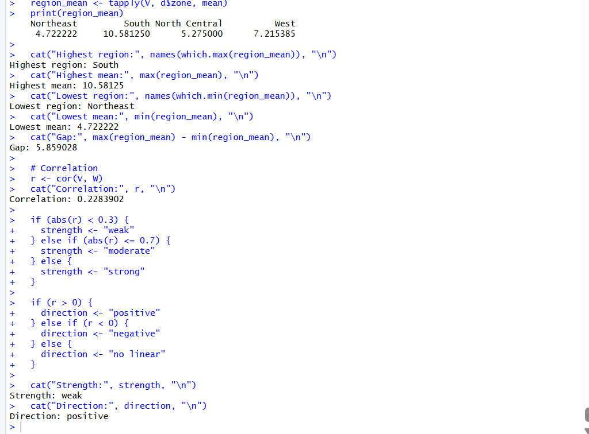
Interpretation: The correlation describes the strength and direction of the linear relationship between land area and murder rate. Correlation does not prove that land area causes a change in murder rate.

Task 3: Classes Change the Story [4 Marks]
Question: Create two maps with four classes: equal interval using cut(V, 4) and quantile using cut(V, quantile(V, seq(0, 1, length.out = 5)), include.lowest = TRUE). Report the lower limit of the top class and the number of states in it for each method. Explain which method makes the highest values look rarer and which you would choose for your audience.
R code:
# Install and load packages
if (!requireNamespace("ggplot2", quietly = TRUE))
install.packages("ggplot2")
if (!requireNamespace("maps", quietly = TRUE))
install.packages("maps")

library(ggplot2)
library(maps)

# Setup data
d <- data.frame(
state = state.name,
zone = state.region,
state.x77
)

names(d) <- c(
"state", "zone", "pop", "income", "illit",
"life", "murder", "hsgrad", "frost", "area"
)

d$id <- tolower(d$state)
V <- d$murder

# Equal-interval classes
equal_class <- cut(V, 4)
equal_breaks <- seq(min(V), max(V), length.out = 5)

# Quantile classes
qbreaks <- quantile(V, seq(0, 1, length.out = 5))

if (anyDuplicated(qbreaks)) {
stop("Quantile breakpoints are duplicated; inspect qbreaks.")
}

quantile_class <- cut(
V, breaks = qbreaks, include.lowest = TRUE
)

# Results
cat("Equal-interval top-class lower limit:",
equal_breaks[4], "\n")
cat("Equal-interval top-class state count:",
sum(V > equal_breaks[4]), "\n")

cat("Quantile top-class lower limit:",
qbreaks[4], "\n")
cat("Quantile top-class state count:",
sum(quantile_class == levels(quantile_class)[4]), "\n")

# Map data
d$equal_class <- equal_class
d$quantile_class <- quantile_class

map_classes <- merge(
map_data("state"), d,
by.x = "region", by.y = "id"
)

map_classes <- map_classes[
order(map_classes$group, map_classes$order), ]

# Equal-interval map
p_equal <- ggplot(
map_classes,
aes(long, lat, group = group, fill = equal_class)
) +
geom_polygon(colour = "white") +
coord_map("albers", lat0 = 29.5, lat1 = 45.5) +
scale_fill_viridis_d(option = "cividis") +
labs(title = "Murder Rate: Equal-Interval Classes",
fill = "Murder rate") +
theme_minimal()

print(p_equal)

# Quantile map
p_quantile <- ggplot(
map_classes,
aes(long, lat, group = group, fill = quantile_class)
) +
geom_polygon(colour = "white") +
coord_map("albers", lat0 = 29.5, lat1 = 45.5) +
scale_fill_viridis_d(option = "cividis") +
labs(title = "Murder Rate: Quantile Classes",
fill = "Murder rate") +
theme_minimal()

print(p_quantile)
Output:
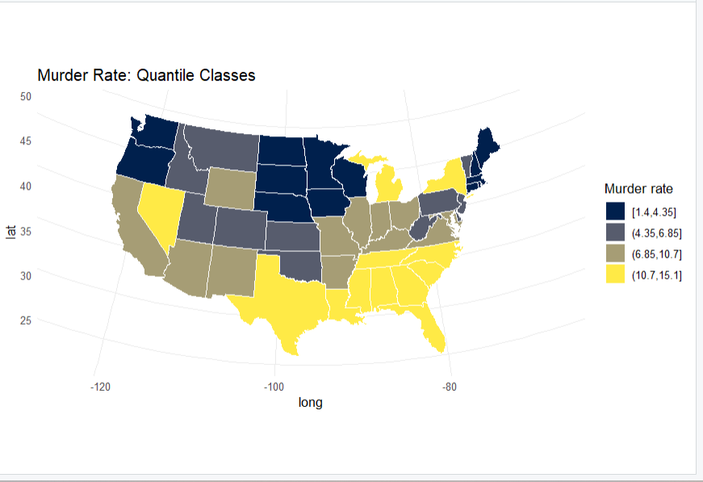
Interpretation: Equal-interval classification uses equal-width ranges and can make unusually high murder rates stand out. Quantile classification places approximately equal numbers of states in each class. I would choose equal intervals to highlight unusually high murder rates.

Task 4: Counts versus Rates [4 Marks]
Question: Calculate the number of murders using count <- d$pop * 1000 * d$murder / 100000. Identify the top three states by count and the top three by murder rate. Report how many states appear in both lists and explain why a map of counts would mislead and what to map instead.
R code:
# Setup data
d <- data.frame(
state = state.name,
zone = state.region,
state.x77
)

names(d) <- c(
"state", "zone", "pop", "income", "illit",
"life", "murder", "hsgrad", "frost", "area"
)

V <- d$murder

# Estimated counts
count <- d$pop * 1000 * d$murder / 100000

# Top three by count
top_count <- order(count, decreasing = TRUE)[1:3]

cat("Top 3 states by estimated count:\n")
print(data.frame(
State = d$state[top_count],
Estimated_Count = round(count[top_count])
))

# Top three by rate
top_rate <- order(V, decreasing = TRUE)[1:3]

cat("Top 3 states by murder rate:\n")
print(data.frame(
State = d$state[top_rate],
Murder_Rate = V[top_rate]
))

# Common states
common_states <- intersect(
d$state[top_count], d$state[top_rate]
)

cat("Number of common states:",
length(common_states), "\n")
print(common_states)
Output:
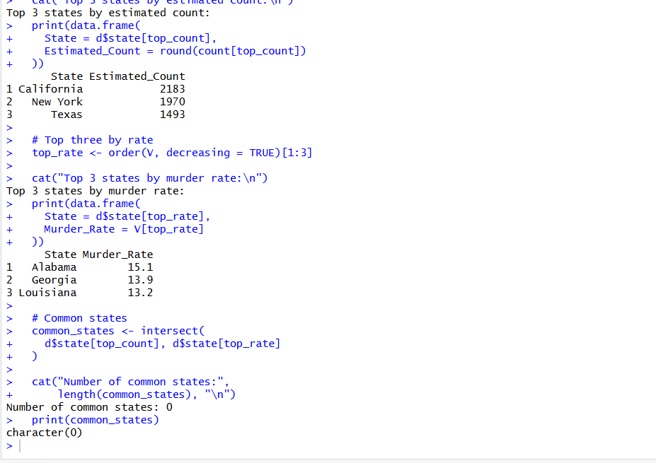
Interpretation: A map of murder counts can mislead because states with larger populations may have more murders simply because more people live there. Murder rates per 100,000 people are more appropriate for comparing states.

Task 5: Tell the Story for the North Central Region [4 Marks]
Question: Report the mean murder rate for North Central and its ratio to the mean of all 50 states. Identify the highest state in North Central and its value, and count the North Central states above the national median. Write a headline of at most 12 words, two evidence sentences using your numbers, and one recommendation for a classroom poster.
R code:
# Setup data
d <- data.frame(
state = state.name,
zone = state.region,
state.x77
)

names(d) <- c(
"state", "zone", "pop", "income", "illit",
"life", "murder", "hsgrad", "frost", "area"
)

V <- d$murder

# National statistics
national_mean <- mean(V)
national_median <- median(V)

# North Central region
nc <- d$zone == "North Central"
nc_mean <- mean(V[nc])

cat("North Central mean:", nc_mean, "\n")
cat("National mean:", national_mean, "\n")
cat("Ratio to national mean:", nc_mean / national_mean, "\n")

# Highest state in North Central
nc_states <- d$state[nc]
nc_rates <- V[nc]

cat("Highest North Central state:",
nc_states[which.max(nc_rates)], "\n")
cat("Highest North Central rate:", max(nc_rates), "\n")

# Number above national median
cat("North Central states above national median:",
sum(V[nc] > national_median), "\n")

Output:
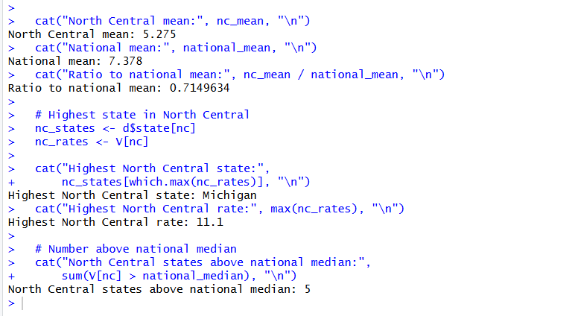

Code of Conduct
I certify that this work is my own.
Signature: A. Yaswanth

